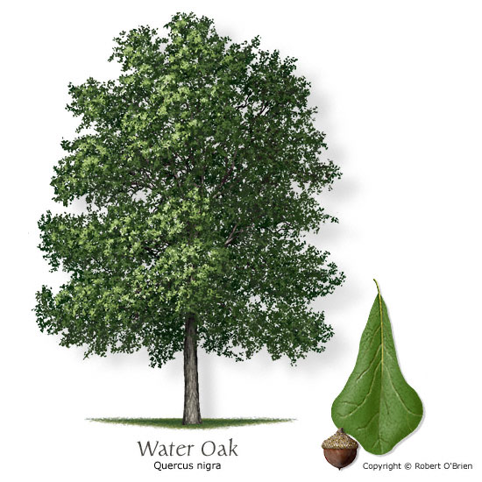Water Oak

*Quercus nigra*

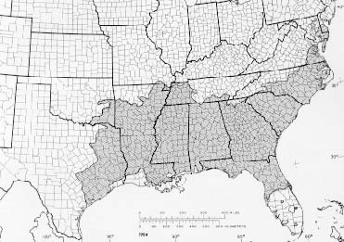

Prepared By: Josh Hall

Collector: Josh Hall

Date: 07/02/13